**Technologies Used: -**

* Node.js
* Express.js
* PostgreSql
* Postman (for testing)

**Assumptions: -**

* To create a new todo user must pass title, priority (depending upon urgency of the task), date (by which the task should be completed), and status of the task (by default the value is set to false i.e.; task is incomplete).
* All fields are mandatory fields.
* Two separate routes are defined to fetch a single todo and all list of todo’s.
* User will be able to update the data on the basis of todo_id which is kept as primary key.
* User will be able to delete todo on the basis of todo_id.

**DATABASE: -**

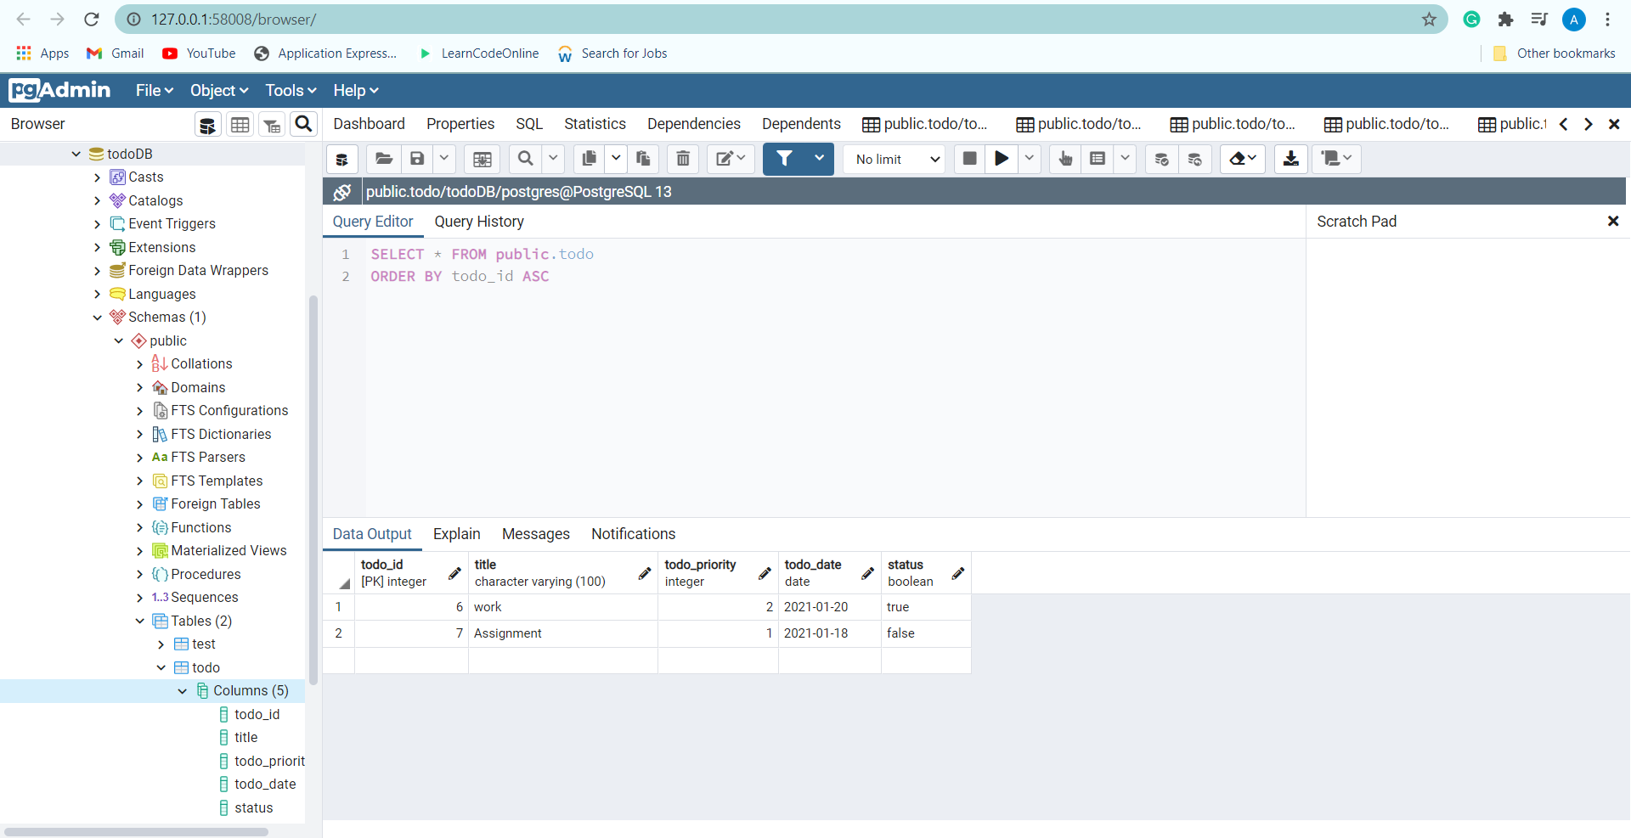

**Steps to run: -**

* install all node dependencies using npm install command.
* Then, in terminal change directory and run npm start command.
* Open the Postman and hit the round that you want to visit by selecting appropriate http request against each route.